**Natural History: Updated 18 May 2020**

Generation interval: time between infection events in an infector-infectee pair

Serial interval: time between symptom onsets in an infector-infectee pair)

Incubation period: time between infection and symptom onset

Disease duration: Time from showing symptoms to death or recovery

Infectious period: Time from becoming infectious to death or recover.

This paper Nishiura gives: Median serial interval = 4.6 days (95% CI: 3.5, 5.9); Mean incubation period is quoted as 5 days. This figure is from their paper

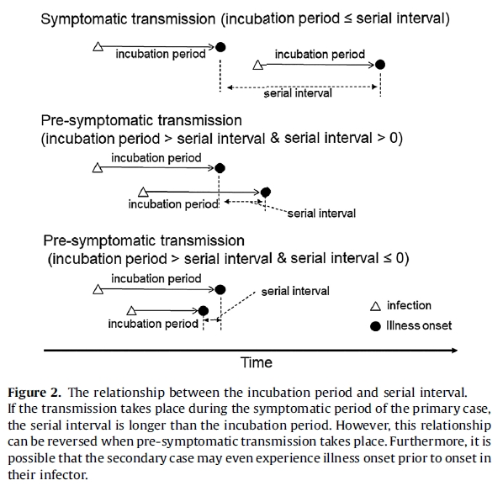

This paper [Ferretti](https://www.dropbox.com/s/xo29tgld6pn4ej3/Science%202020%20Ferretti.pdf?dl=0) considers old-fashioned contact tracing and the benefits of electronic (App) contact tracing and concludes that: ‘If this is an accurate picture of viral spread in Europe and not an arte-fact of early growth, epidemic control with only case isolation and quarantining of traced contacts appears implausible in this case, requiring near-universal App usage and near-perfect compliance. The App should be one tool among many general preventative population measures such as physical distancing, enhanced hand and respiratory hygiene, and regular decontamination.’

They are comparing traditional contact tracing with contact tracing using Apps and conclude that it will not be sufficient to control the epidemic.

This paper [Tapiwa](https://www.dropbox.com/s/biudtz00bmmvbtc/MedRxiv%202020%20Tapiwa.pdf?dl=0) says that ‘The mean generation interval was 5.20 (95%CI 3.78-6.78) days for Singapore and 3.95 (95%CI 3.01-4.91) days for Tianjin, China when relying on a previously reported incubation period with mean 5.2 and SD 2.8 days. The proportion of pre-symptomatic transmission was 48% (95%CI 32-67%) for Singapore and 62% (95%CI 50-76%) for Tianjin, China.’

I thought I might as well try to be clear about the notation and produced this.

Disease duration

Infectious

Symptomatic

Dead or

recovered

Infectious

Pre-symptomatic

Infected

Serial interval

Generation time

Infectious

Symptomatic

Dead or

recovered

Infectious

Pre-symptomatic

Infected

Infectious period

Incubation period

Figure 1: Case history of Infector-Infectee Pair

The way it is presented the generation time and the serial interval are the same. In a stochastic model they could each be chosen suitable distributions and could therefore be different for particular infection events. I hope this clarifies things and does not muddy the already muddied water!

The overall conclusion then is that:

* Incubation period ~ 4-5 days
* Infections: ~50% pre-symptomatic and ~50% asymptomatic.
* Serial interval: ~5 days.

Duration of symptomatic and symptomatic disease not clear. Assuming that pre-symptomatics are half as infectious as symptomatics and that people are infectious for 15 days, we might guess that the asymptomatic period is 10 days and the symptomatic period is 5 days. Then we have the infections as indicated in the figure.

**Estimating *R*0 directly from data**

Ideally one would estimate *R*0 from an appropriate dynamical model but it is worth considering how close we can get simply from time series of data on cases.

Consider the schematic in Figure 1. If we assume that people become cases as soon as they become symptomatic, then the people at the bottom of Figure 1 could not have been infected by any of the those who developed symptoms in the previous five days since they were still uninfectious when the person at the bottom was infected as shown by the brown line. They could have been infected by any of those who became cases between 5 and 15 days earlier in the pre-symptomatic stage (blue lines) or any of those who became cases between 15 and 20 days earlier in the symptomatic stage. This all assumes durations for the asymptomatic, pre-symptomatic and asymptomatic stages. The expected number of cases on any day is then

where ** and ** are the relative infectiousness of the two stages.

\

Infection status of people who present as cases (red dots) on successive days

Time

Infected

uninfectious

Presymptomatic

Symptomatic

Figure 2. Schematic diagram of Covid infections. Each horizontal line represents a day. People show symptoms and are recorded as cases as indicated by the left most red dot. On a given day such a person was infected some days earlier as indicated by the left most green dot remains uninfectious for a while, becomes pre-symptomatic for the period indicated by the blue line, becomes symptomatic and remains so as indicated by the red line until they die or recover.

Since we are only going to need relative values we can set ** to 1 and ** to 0.5 if the pre-symptomatics are half as infectious as the symptomatics. Now we know that if the numbers are constant over time *R*0  1 so we need to normalize by dividing the denominator by 5** +10**  . This gives as the estimate of *R*(*d*) which is to mean *Rt* or *Reffective* or whatever we choose to call it on day *d* as

$$R\left(d\right)=\frac{C_{d}}{\left(π\sum_{i=6}^{15}{C_{d-i}}+σ\sum_{i=16}^{20}{C_{d-i}}\right)/(10π+5σ)}$$

or

$$R\left(d\right)=\frac{C_{d}}{\left[(1-ρ)\sum_{i=6}^{15}{C_{d-i}}+ρ\sum_{i=16}^{20}{C_{d-i}}\right]/[10(1-ρ)+5ρ]}$$

where 0 < *  * is the infectiousness in the symptomatic given as a proportion compared to (1- $ρ)$ for the pre-symptomatic phase.

We then estimate *R*0 as the ratio of the observed to expected number of cases on a given day. Applying this to the time series data for cases in the United Kingdom we get the result shown in Figure 2.



Figure 3. Estimated values of *R*0 for the United Kingdom.

Figure 2 (below) suggests that the apparently very high estimates at the start were the result of

increasing testing rather than increasing infections. Starting from about the 9th April the testing rate was fairly constant and here is a massive kick at the end so I have taken the data from the 9th April to the 30th April and plotted these on a log scale in Figure 3. This suggests that *R*0 has indeed fallen from about 2.28 (1.97−2.63) to 0.69 (0.59−0.79) over this period.

Just watching the 8:00 news on the BBC (3 May), as I type, and they have just said (I quote): The R-number is 0.7

**Reanalysis based on the Brief Communication by He et al (2020)**

This Brief Communication describes the analysis of 77 infector-infectee pairs yielding estimates of 5.8 days for the serial interval, and citing Li et al. as giving the mean incubation period as 5.2 days From this He et al infer that infectiousness starts 2.3 days and peaks just 0,7 days before symptom onset, giving an estimated proportion of infections of 44% as occurring before the onset of infector symptoms. Infectiousness then declined within 7 days.

These findings are depicted in Fig.4.

Case Duration (~12days)

Infectiousness Duration (~9days)

Median

Infectiousness

44%

**Days**

Symptomatic

Incubation

Period

Infector

Incubation

Period

Symptomatic

Infectee

Serial Interval

Figure 4: Schematic of Infector-Infectee Relationship as described by He et al.